Cat /etc/os-release

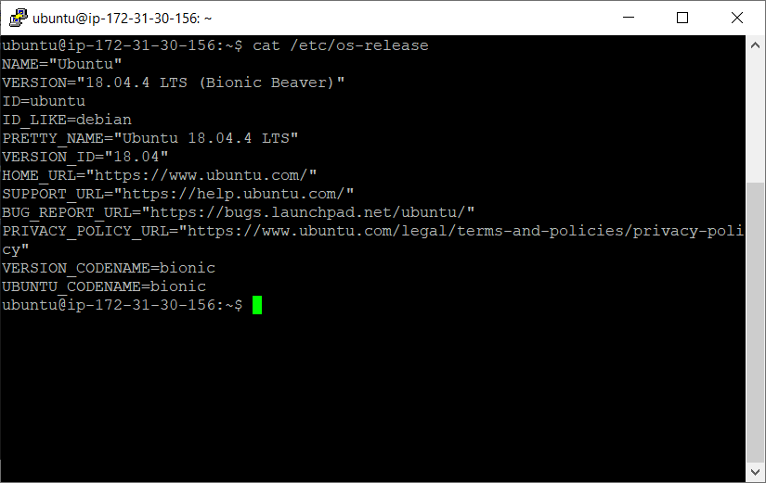

hostnamectl

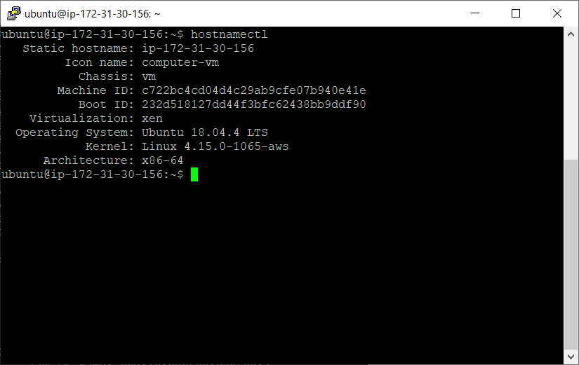

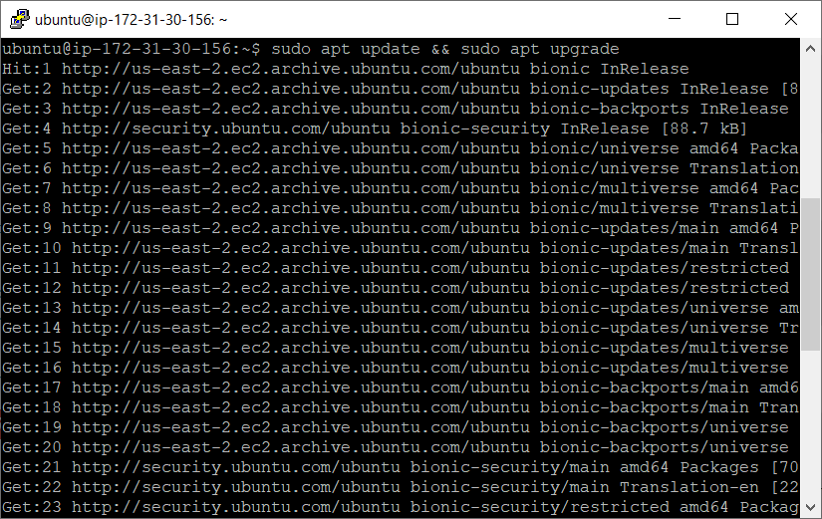

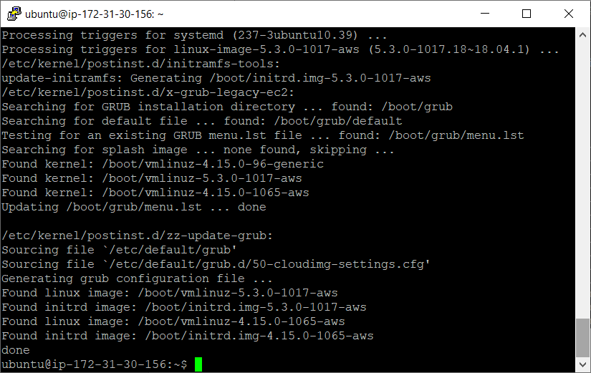

Installing Java

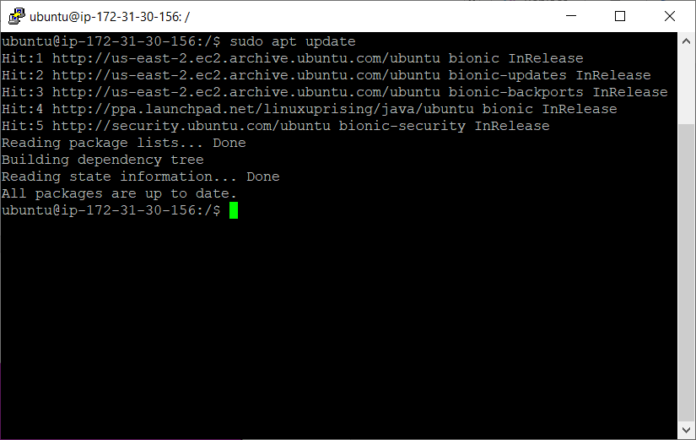

**Remove JAVA_HOME from below location :-**

sudo vi /etc/environment

**To uninstall OpenJDK (if installed). First check which OpenJDK packages are installed.**

sudo dpkg --list | grep -i jdk

**To remove openjdk:**

sudo apt-get purge openjdk*

**Uninstall OpenJDK related packages.**

sudo apt-get purge icedtea-* openjdk-*

**Check that all OpenJDK packages have been removed.**

sudo dpkg --list | grep -i jdk

**Install Java:-**

**sudo apt install default-jdk**

**Check Version of Java**

**java - version**

sudo apt install default-jre

sudo apt install openjdk-11-jre-headless

sudo apt install openjdk-8-jre-headless

Got Error :- E: Sub-process /usr/bin/dpkg returned an error code (1)

How to Fix?: -

If your package database has become corrupted, reconfiguring it can repair it.

Enter the following command:

**sudo apt dpkg ––configure –a**

This command reconfigures packages that have been unpacked but not necessarily installed. An interruption at the wrong time can cause this database to become corrupt. This is especially helpful if you were running installation and the process was interrupted.

**Set the JAVA_HOME Environment Variable**

Some applications written in Java are using the JAVA_HOME environment variable to determine the Java installation location.

To set the JAVA_HOME environment variable, first, you need to find out the Java installation paths using the update-alternatives command

The preferred location for **JAVA_HOME** or any system variable is **/etc/environment**.

Open **/etc/environment** in any text editor like nano or gedit or vi using root privileges , you can use sudo ….. and add the following line:

JAVA_HOME="/usr/lib/jvm/<name of the directory>"

(java path could be different)

Use source to load the variables, by running this command:

**source /etc/environment**

Then check the variable, by running this command:

**echo $JAVA_HOME**

**or**

**printenv**

**INSTALL GIT on Ubuntu on AWS**

**Step 1: Update Default Packages**

Logged into your Ubuntu 18.04 server as a sudo non-root user, first update your default packages.

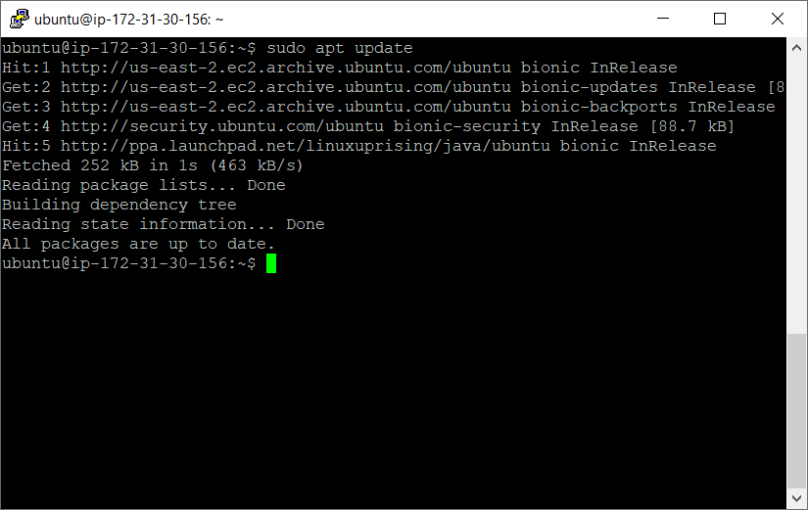

**Step 2 — Install Git**

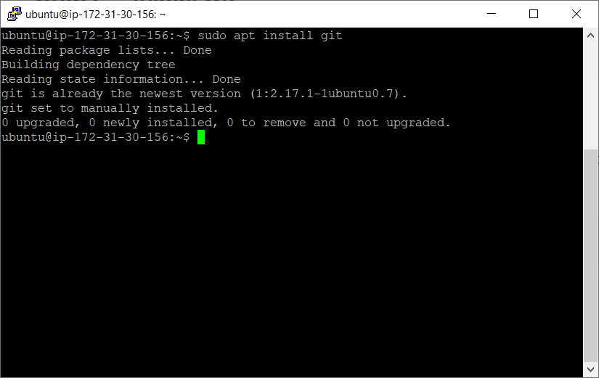

**Step 3- Confirm the git version**

**git --version**

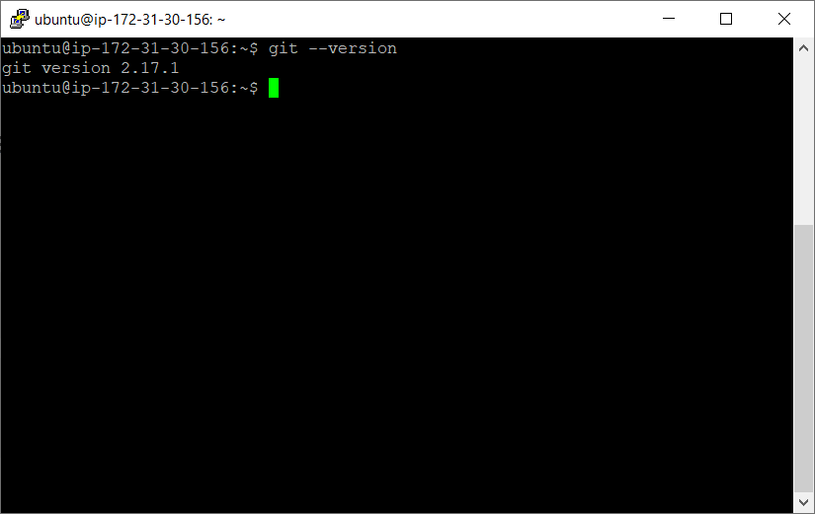

**Step 4 — Set Up Git**

Now that you have Git installed and to prevent warnings, you should configure it with your information.

git config --global user.name "Your Name"

git config --global user.email [youremail@domain.com](mailto:youremail@domain.com)

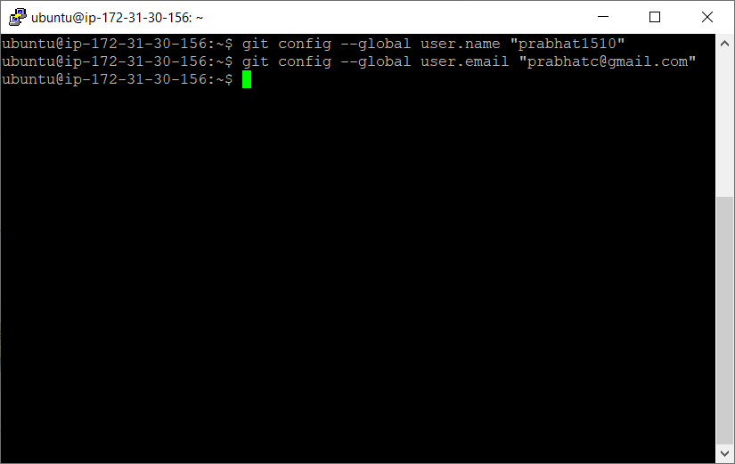

If you need to edit this file, you can use a text editor such as vi:

vi ~./gitconfig

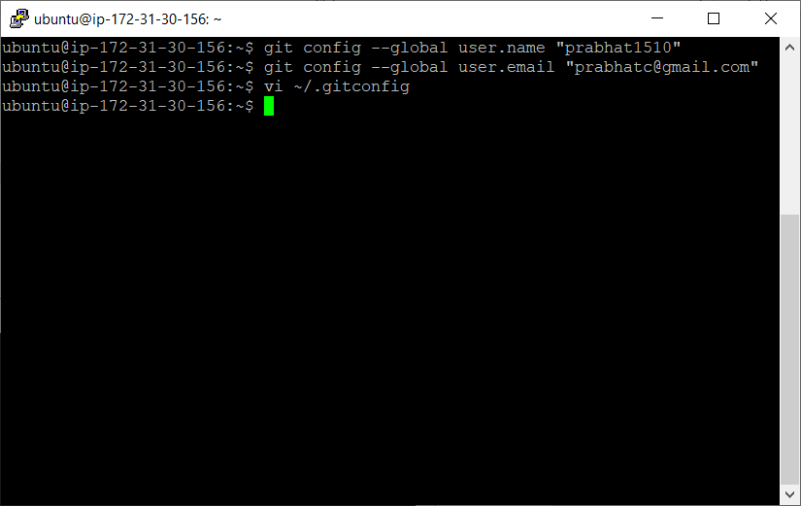

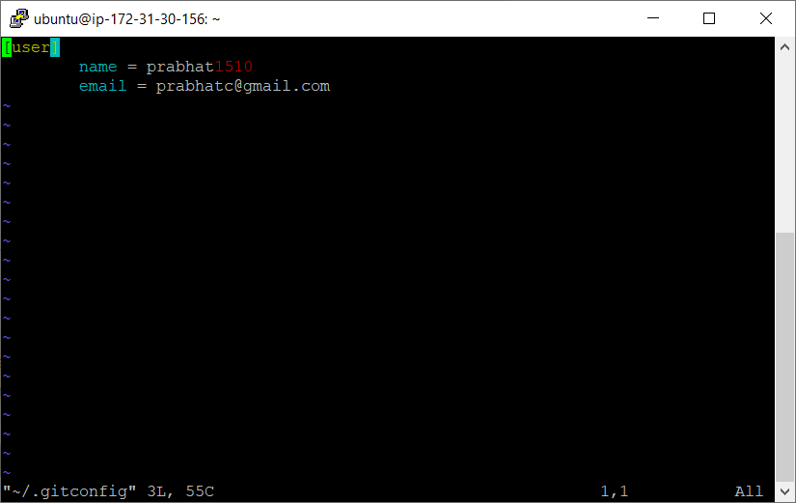

**Step 5 — Creating a local repository**

git init repoName

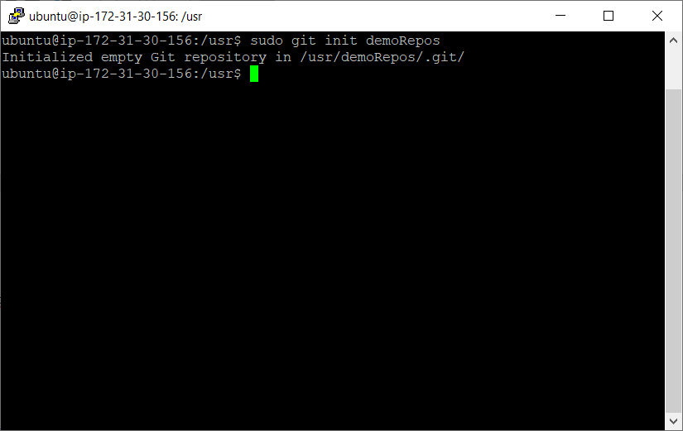

Change directory

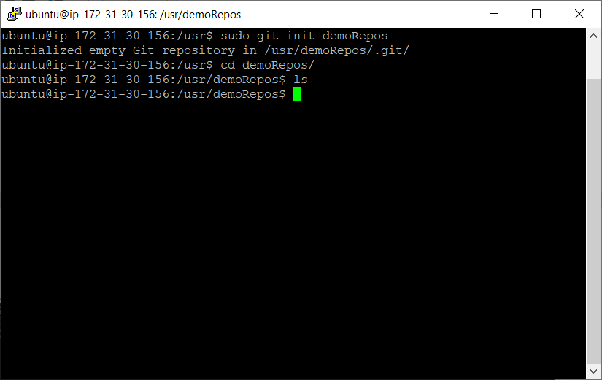

**Step 6 --Creating a README file to describe the repository**

You can use any other text editors. I have used gedit/vi. If its not there install it using below commands

sudo apt install gedit

I am using vi editor

Esc :wq save and quit.

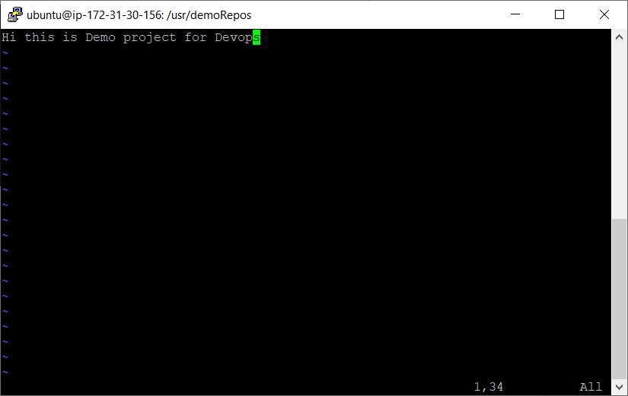

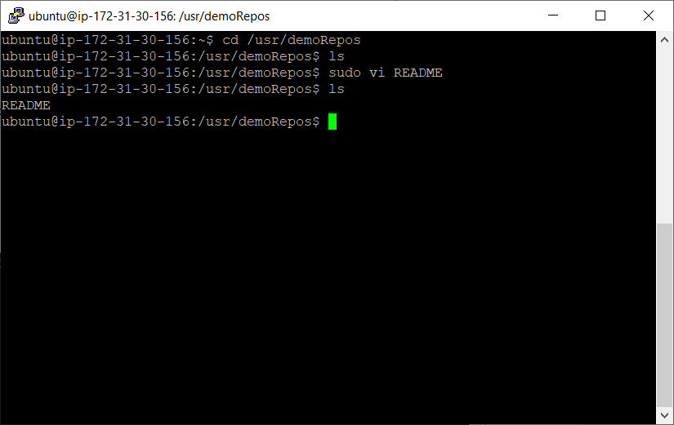

Create another file

Name it HelloWorld.java

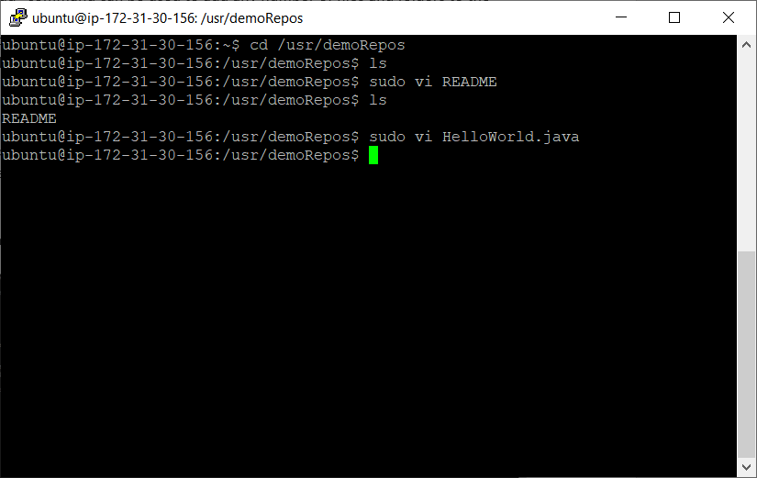

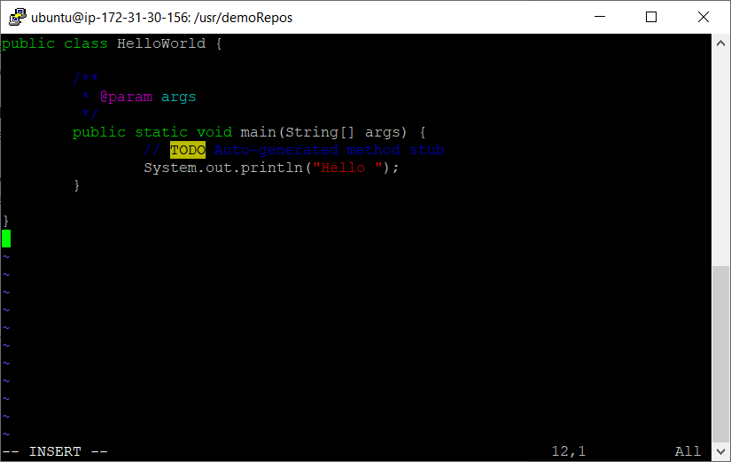

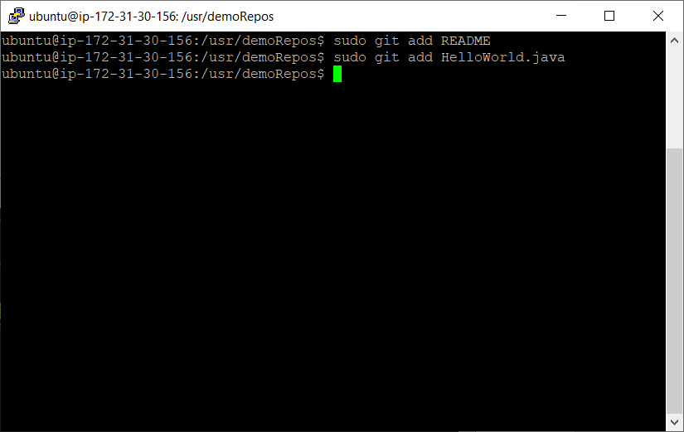

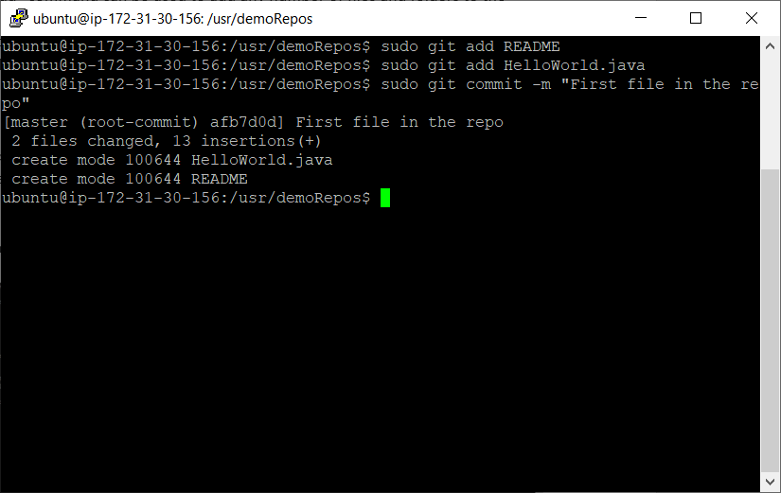

Step 7 check on git repository

If directory is not initialized then use

git init repoName (or directory name)

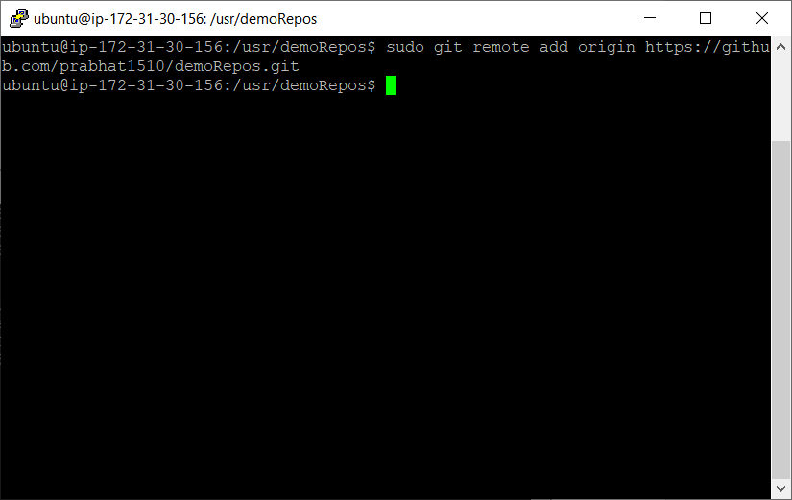

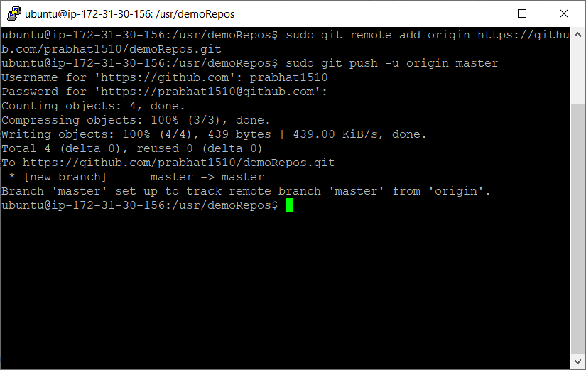

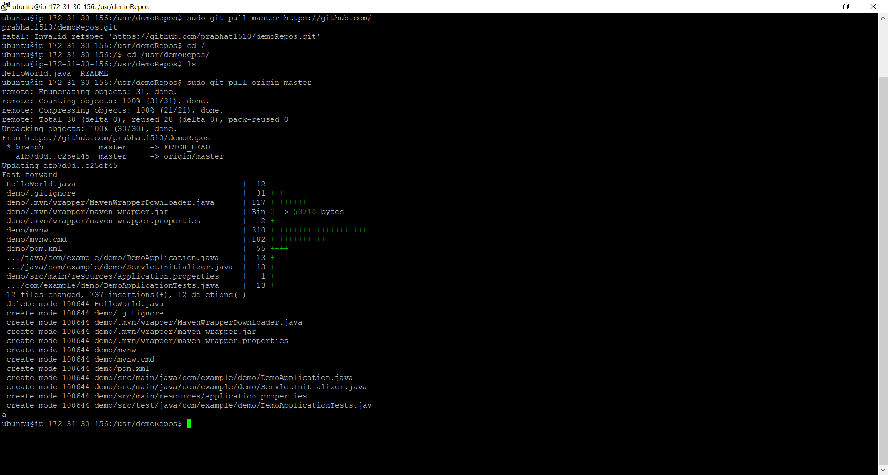

Installing maven :

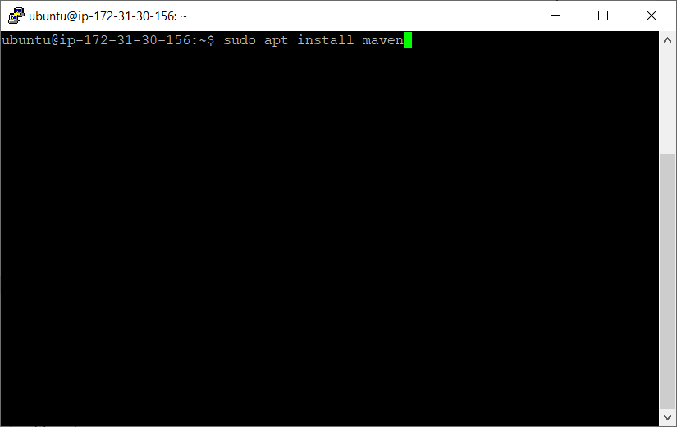

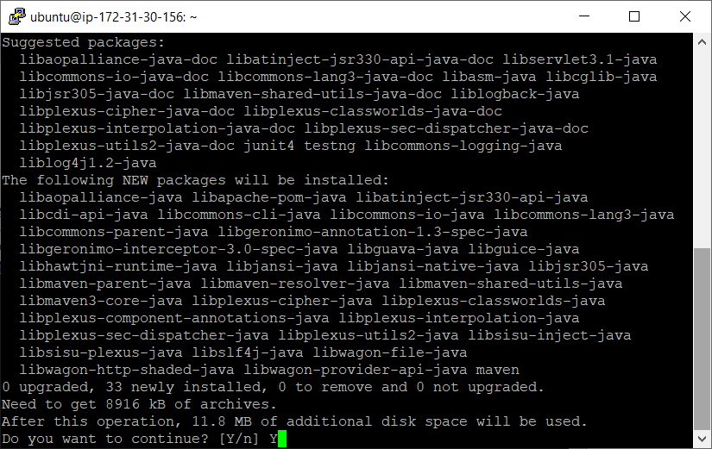

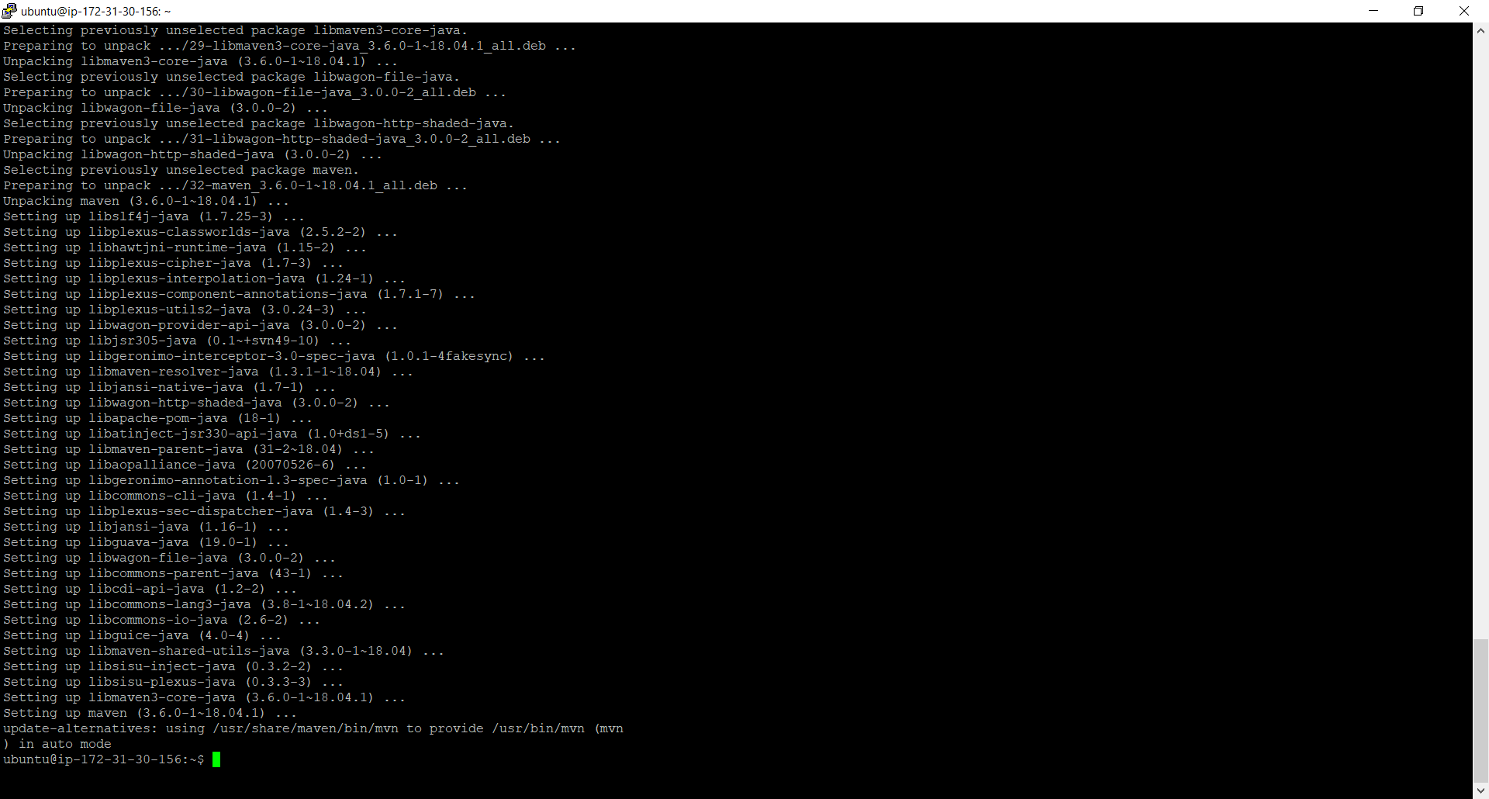

**Check maven version:**

mvn -version

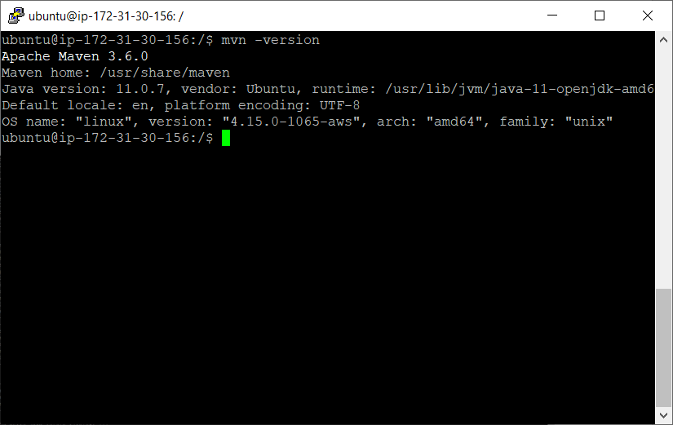

**Set MAVEN_HOME in environment variable /etc/environment**

**MAVEN_HOME="/usr/share/maven"**

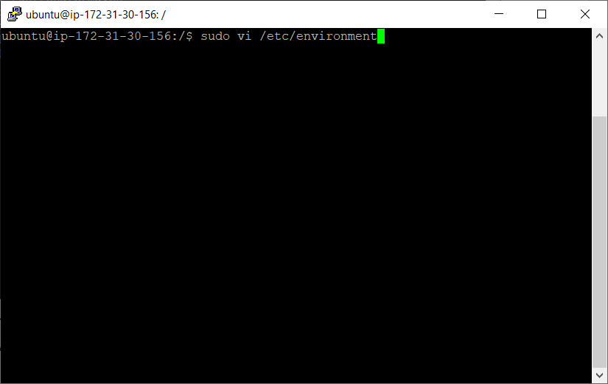

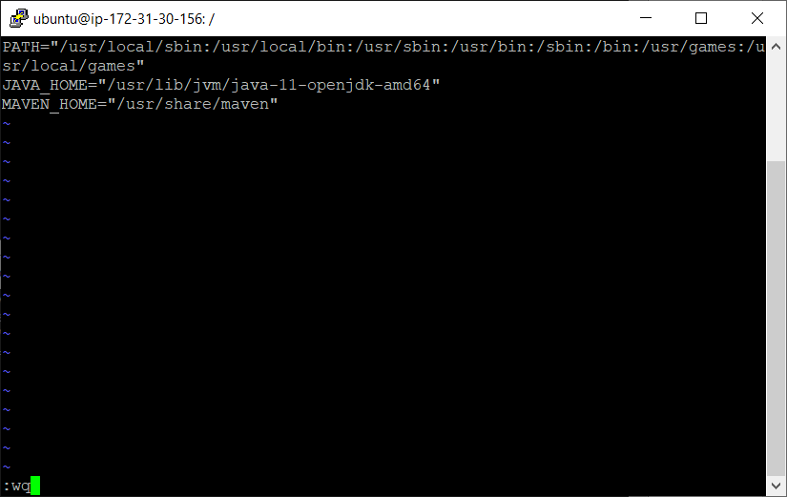

**Load Environment variable using source**

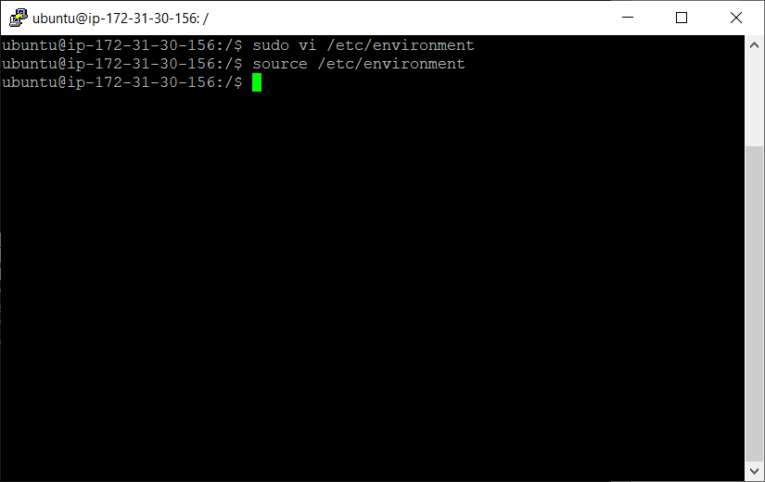

**Confirm that MAVEN_HOME is configured or not**

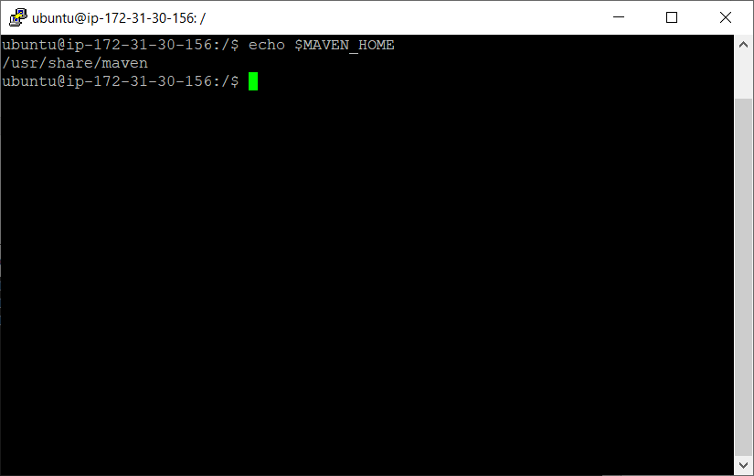

Installing Jenkins

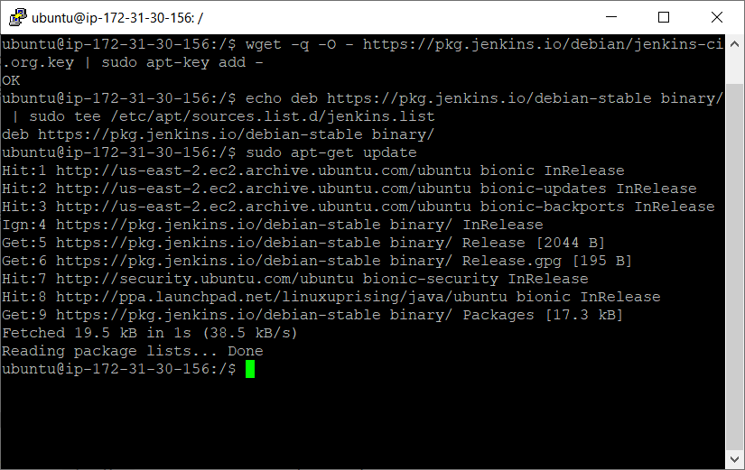

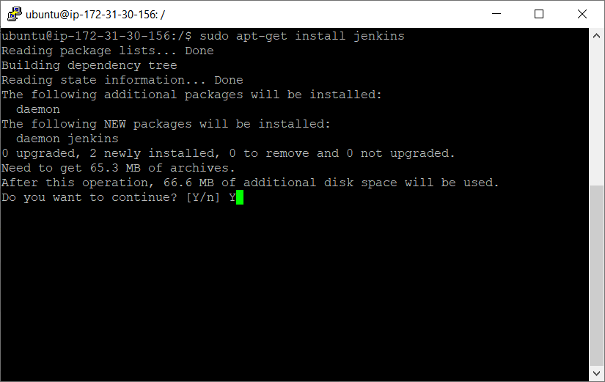

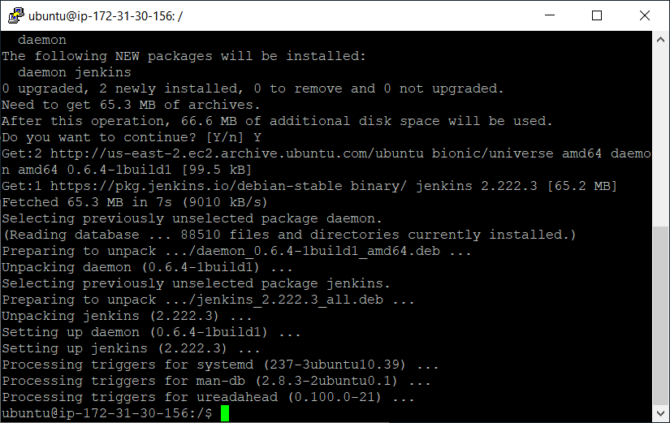

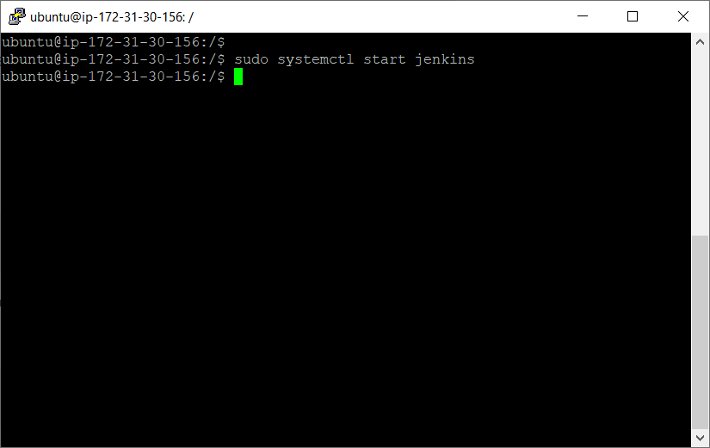

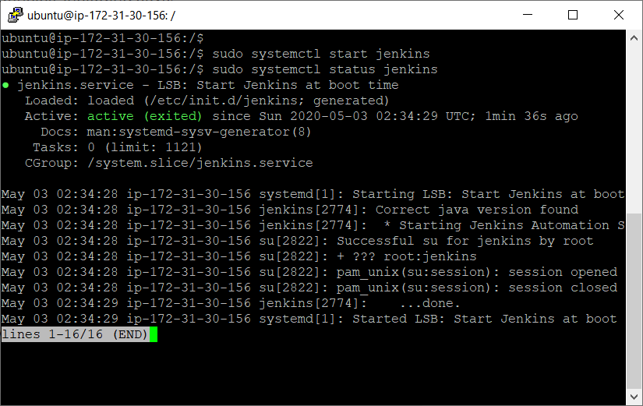

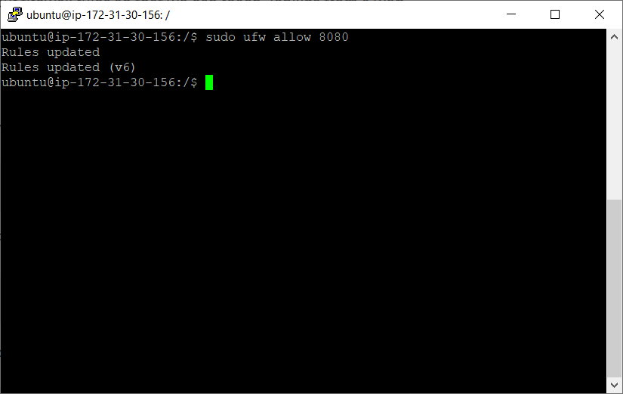

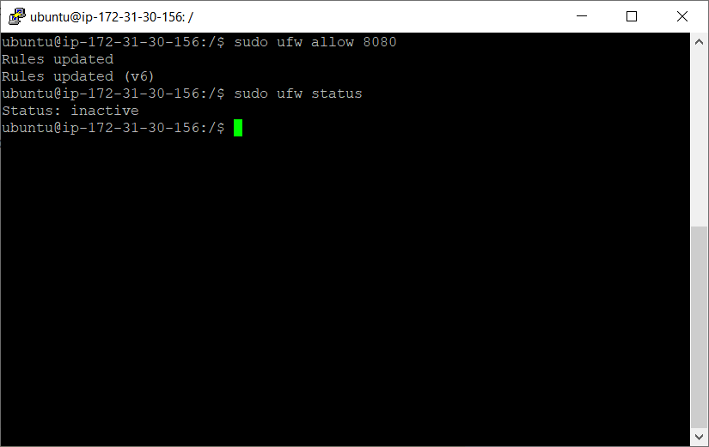

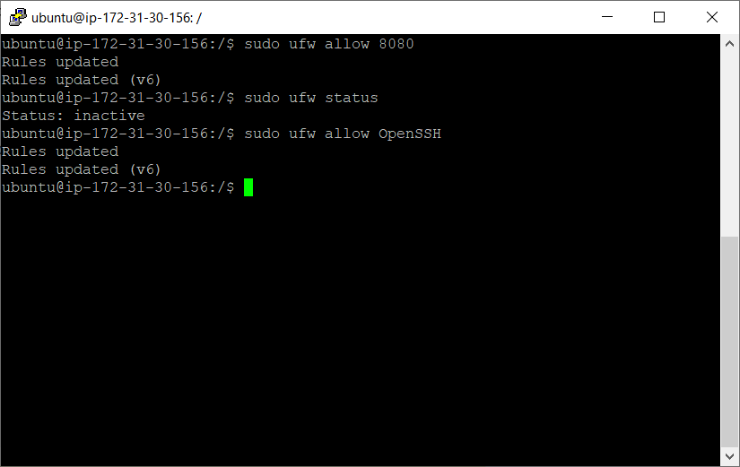

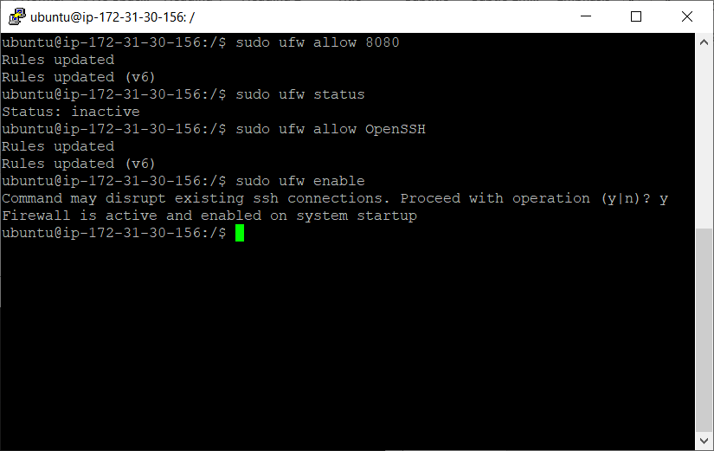

Jenkins url ec2 instance url and port number 8080

